SQL ASSINGMENT 1

Ques 1.) Creating sample tables and inserting values.

Create the following tables with the given structures and insert sample data as specified :-

A) SALESPEOPLE
Snum int(4)
Sname varchar(10)
City varchar(10)
Comm float(3,2)
**Creating table sales people :--
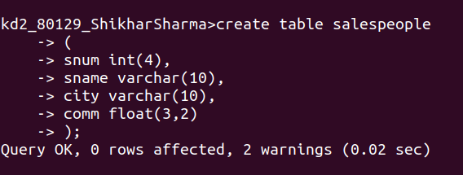

** Inserting given data :--

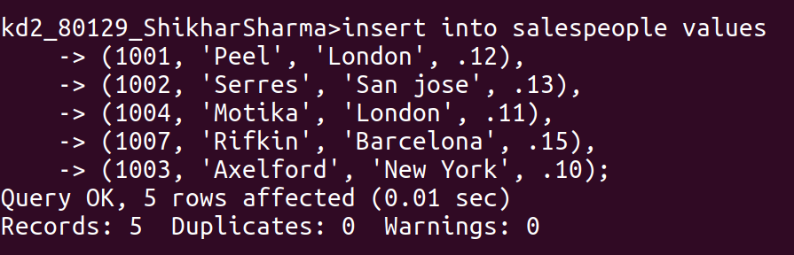

**Table Output :--

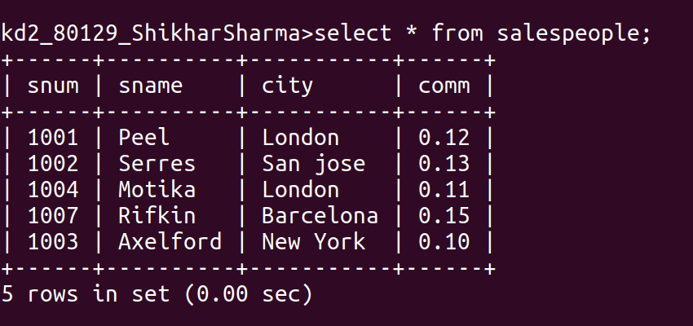

B) CUSTOMERS
Cnum int(4)
Cname varchar(10)
City varchar(10)
Rating int(4)
Snum int(4)

**Creating table customers :--
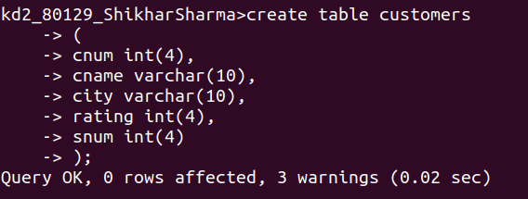

** Inserting the given data :--
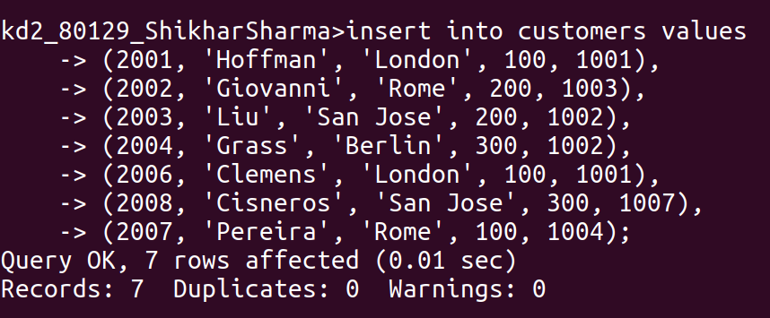

**Table output :--

C) ORDERS
Onum int(4)
Amt float(7,2)
Odate date
Cnum int(4)
Snum int(4)

** Creating table orders :--
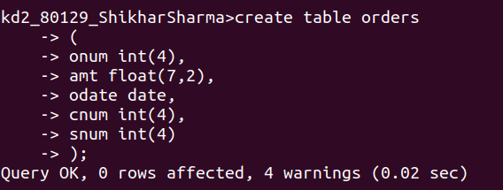

** Inserting the given data :--
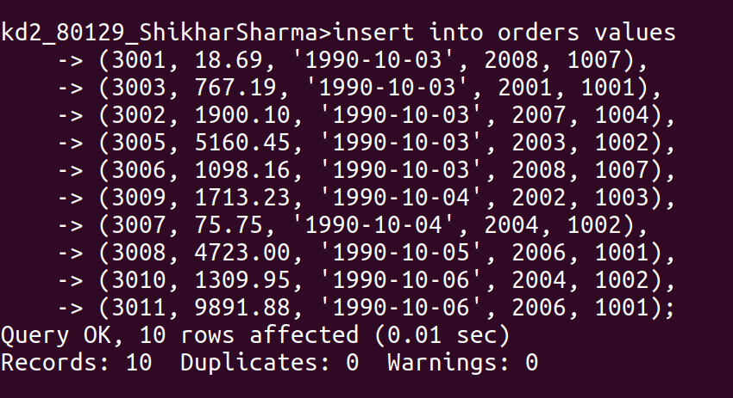

** Table output :--

